Name-Ujjawal Mandhani
Batch-F6
Enroll no.-9918103237
OSS LAB Practice Session 3

Ans -1:
function selectionSort(inputArr) {
let n = inputArr.length;

for(let i = 0; i < n; i++) {
let min = i;
for(let j = i+1; j < n; j++){
if(inputArr[j] < inputArr[min]) {
min=j;
}
}
if (min != i) {
let tmp = inputArr[i];
inputArr[i] = inputArr[min];
inputArr[min] = tmp;
}
}
return inputArr;
}
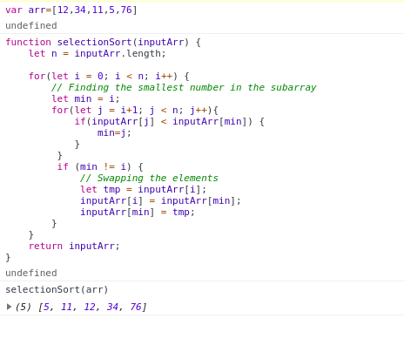

Ans -2:

<!DOCTYPE html>
<html>

<head>
<script>
function validateform() {
var name = document.myform.username.value;
var password = document.myform.password.value;
var user = document.myform.user.value;
var Number = /^[0-9]+$/;
if (user == "employee") {
if (name.length != 8) {
alert("name should be length 8");
return false;
}
var g1 = name.slice(0, 2);
var g2 = name.slice(2, 6);
var g3 = name.slice(6, 8);
if (g2 != "BARN") {
alert("Username contain company name");
}
if (!g3.value.match(Number)) {
alert("last 2 digit must be number");
return false;
}

}
else {
if (name.length != 10) {
alert("name should be length 10");
return false;
}

if (!(name.value.match(Number))) {
alert("all letter must be number");
return false;
}

}
if (password.length < 6) {
alert("Password length should be minimum 6");
return false;
}
var tmp = {};
for (var i = 0; i < name.length; i++) {
var c = name.charAt(i);
if (c in tmp) {
alert("letter should not be repeated");
return false;
}
else {
tmp[c] = 1;
}
}
alert("You have successfully logged in");
return true;
}
</script>
</head>

<body>
<form name="myform" onsubmit="return validateform()" action="#" method="post">
User : <select name="user">
<option value="student">student</option>
<option value="employee">employee</option>
</select><br>
Username : <input type="text" name="username" required><br>
Password : <input type="password" name="password" required><br>
<input type="submit" value="Submit">
</form>
</body>

</html>

